Relative Clause as a modifier

🔹 What Is Relative Clause as a modifier?
# Source: AI Source: Provided by: [Data Path: Persons Table -> ID Column: 1, Name_En Column: Motasem Essam] -> From: [Chatgpt (GPT‑5 Mini)] on [8/7/2025]
A relative clause (also called an adjective clause) is a dependent clause that modifies a noun or pronoun by giving more information about it.
It usually begins with a relative pronoun (who, whom, whose, which, that) or a relative adverb (where, when, why).

🔸 Structure:
# Source: AI Source: Provided by: [Data Path: Persons Table -> ID Column: 1, Name_En Column: Motasem Essam] -> From: [Chatgpt (GPT‑5 Mini)] on [8/7/2025]
[Relative Pronoun/Adverb] + [Subject] + [Verb]

🔸 Examples:
# Source: AI Source: Provided by: [Data Path: Persons Table -> ID Column: 1, Name_En Column: Motasem Essam] -> From: [Chatgpt (GPT‑5 Mini)] on [8/7/2025]
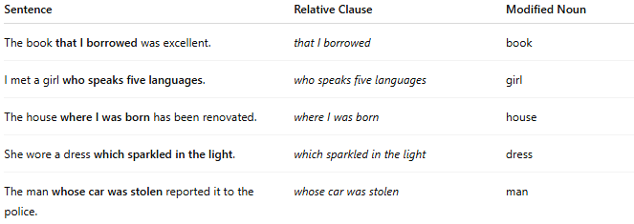
Sentence | Relative Clause | Modified Noun
The book that I borrowed was excellent. | that I borrowed | book
I met a girl who speaks five languages. | who speaks five languages | girl
The house where I was born has been renovated. | where I was born | house
She wore a dress which sparkled in the light. | which sparkled in the light | dress
The man whose car was stolen reported it to the police. | whose car was stolen | man

🔸 Types of Relative Clauses:
# Source: AI Source: Provided by: [Data Path: Persons Table -> ID Column: 1, Name_En Column: Motasem Essam] -> From: [Chatgpt (GPT‑5 Mini)] on [8/7/2025]
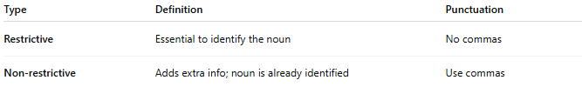
Type | Definition | Punctuation
Restrictive | Essential to identify the noun | No commas
Non-restrictive | Adds extra info; noun is already identified | Use commas
Examples:
- The students who study hard pass the exam. (Restrictive)
- My brother, who lives in Canada, is visiting. (Non-restrictive)

🔸 Relative Pronouns Chart:
# Source: AI Source: Provided by: [Data Path: Persons Table -> ID Column: 1, Name_En Column: Motasem Essam] -> From: [Chatgpt (GPT‑5 Mini)] on [8/7/2025]
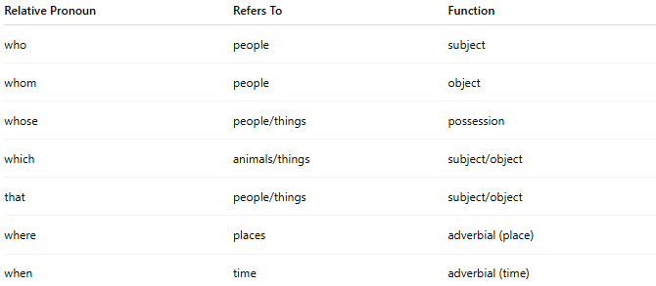
Relative Pronoun | Refers To | Function
who | people | subject
whom | people | object
whose | people/things | possession
which | animals/things | subject/object
that | people/things | subject/object
where | places | adverbial (place)
when | time | adverbial (time)

